C:\DOKUME~1\mbal\LOKALE~1\Temp\Rar$DR00.734\TUC deutsch RGB.wmf

Department of Electrical Engineering and Information Technology

Chair of Measurement and Sensor Technology



**Project Documentation**

„Project Lab Embedded Systems“

Group: 02

Members: Jagadish Subrayan Potty Harikrishnan

Koravuna Shamini

Michael Joy Mathew

Uday Kumar Surepally

Project: 3D Printer Update and Troubleshooting

Date: 2017-04-01

**Table of Contents**

1 Abstract 1

2 Member Responsibilities 1

3 About 3D Printer 1

4 Prusa i3 ..............................................................................................................................3

4.1 Mechanical components 3

4.2 Electrical components 8

4.3 Steps to assemble Prusa i3 Printer 9

4.4 Calibration of X, Y and Z axes 10

4.5 Filling the extruder with Filament **……………………………………………………………………**12

5 Software 13

6 Firmware update and trouble shooting 15

7 Possible Hardware faults and its solutions 17

8 Further updates 20

9 Conclusion 21

10 Reference 22

# Abstract

3D Printing has been around since the early twentieth century and was unfold from automated production. Not long ago, its applications were made progress to other industries, including medical, aerospace, construction, etc. This report explores the basic working of a 3D Printer, possible faults that could occur and its solution(s). Moreover a description on Prusa i3 version and its firmware update is explained in detail. Finally, a future modification on Prusa i3 is discussed.

# Member Responsibilities

Jagadish Subrayan Potty Harikrishnan Mechanical troubleshooting

Koravuna Shamini Firmware update

Michael Joy Mathew Electrical troubleshooting

Uday Kumar Surepally Electronics troubleshooting

# About 3D Printer

3D Printing is a process that creates a physical model from a digital design. There are different 3D printing technologies, but all are based on the same principle: a digital model is turned into a solid three-dimensional physical object by adding material layer by layer.

This is how it works. AM (Additive manufacturing) is the means of creating an object by adding material to the object layer by layer. These layer up to form a solid object.

All 3D printing technologies create physical objects by using its method. One of the most common technology for 3D Printing is Fused Deposition Modelling (FDM).

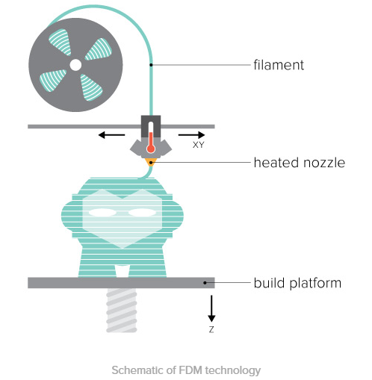

The FDM printing process starts by using a solid material known as the filament. This line of filament is forced from a reel attached to the 3D printer to a preheated nozzle that melts the material. Once the filament is melted, it can be extruded in a determined and particular way as it has been instructed by the microcontroller and the software. It instantly cools and solidifies as the material is extruded as a layer. It then bestows as the platform for the next layer of material extruded until the entire object is printed.

Other technologies used are:

* [Stereolithography(SLA)](http://3dprintingfromscratch.com/common/types-of-3d-printers-or-3d-printing-technologies-overview/#sla)
* [Digital Light Processing(DLP)](http://3dprintingfromscratch.com/common/types-of-3d-printers-or-3d-printing-technologies-overview/#dlp)
* [Selective Laser Sintering (SLS)](http://3dprintingfromscratch.com/common/types-of-3d-printers-or-3d-printing-technologies-overview/#sls)
* [Selective laser melting (SLM)](http://3dprintingfromscratch.com/common/types-of-3d-printers-or-3d-printing-technologies-overview/#slm)
* [Electronic Beam Melting (EBM)](http://3dprintingfromscratch.com/common/types-of-3d-printers-or-3d-printing-technologies-overview/#ebm)
* [Laminated object manufacturing (LOM)](http://3dprintingfromscratch.com/common/types-of-3d-printers-or-3d-printing-technologies-overview/#lom)

**4** Prusa i3

The Prusa i3 is the most communal [modelling](https://en.wikipedia.org/wiki/Fused_deposition_modeling) [3D printer](https://en.wikipedia.org/wiki/3D_printer) around. The Prusa i3 is capable of printing many materials including [Acrylonitrile Butadiene Styrene (ABS)](https://en.wikipedia.org/wiki/Acrylonitrile_butadiene_styrene), [Poly-Lactic Acid (PLA)](https://en.wikipedia.org/wiki/Polylactic_acid), High Impact [Polystyrene](https://en.wikipedia.org/wiki/Polystyrene) (HIPS) and [nylon](https://en.wikipedia.org/wiki/Nylon) considering the hot end and heat bed installed. The purpose of this report is to update the firmware to get rid of any bugs. And on the top of that, mechanical and electrical troubleshooting is analysed (which will be discussed in detail later). Figure shows the basic block diagram of Prusa i3.

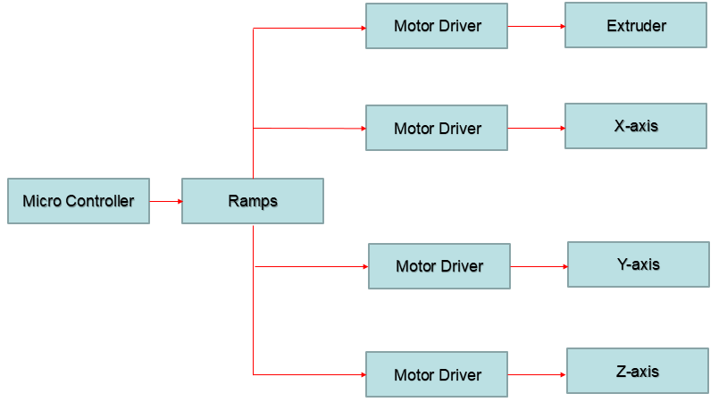

Block diagram of Prusa i3

Components of the device can be classified both electrically as well as mechanically.

### **4.1** Mechanical components:

* **Heat bed:** It is the surface on which models are printed to. Consists of a sheet of glass, a heating material, and a surface on top to help the filament hold. Most print beds are heated for holding the model from deforming while it is being printed.

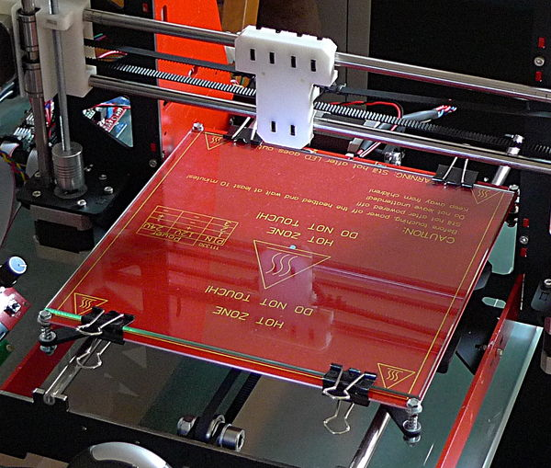

Print Bed

### **Bed surface:** It helps the filament stick to the bed during printing but also permit it to be removed easily when the print process is done.

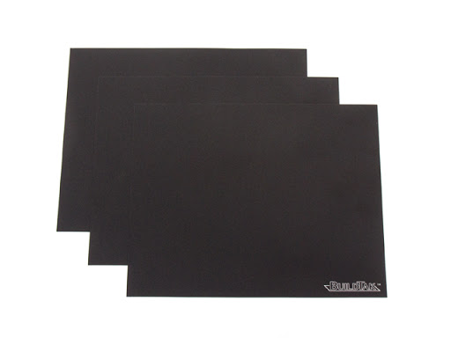

Heat Bed Surface

* **Extruder:** The extruder is the principal component of the printer. It helps the filament to get in, then it gets melted and thrust out. The extruder consists of two parts; the hot end and the cold end. The cold end has a motor that heaves the filament in and pushes it through. The hot end (Thermistor) is where the filament gets melted and popped out.

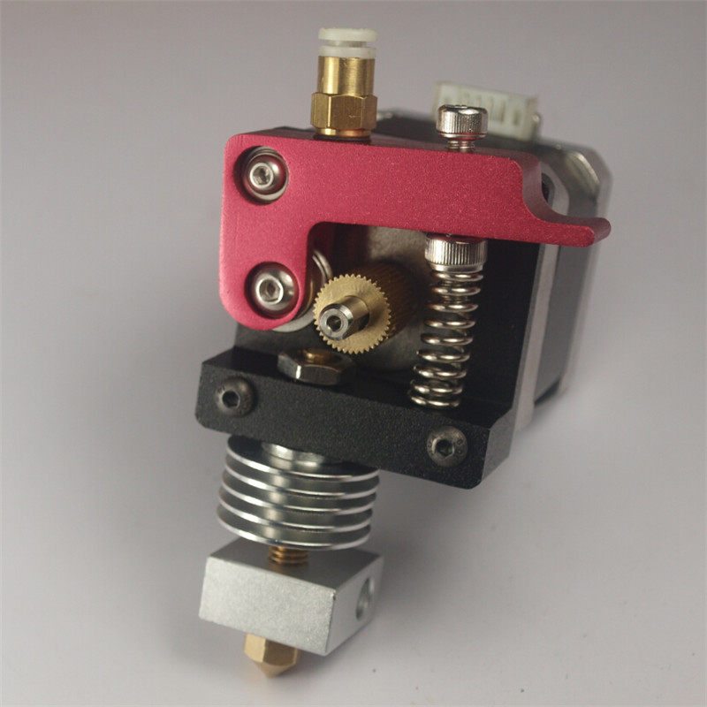

Extruder with Thermistor on bottom

### **Heat Sink: It** fortifies that heat does not whizz up the filament and melt it before it reaches the nozzle. This condition is known to be heat creep and it induces jams. A fan should be running when the hot end is warm.

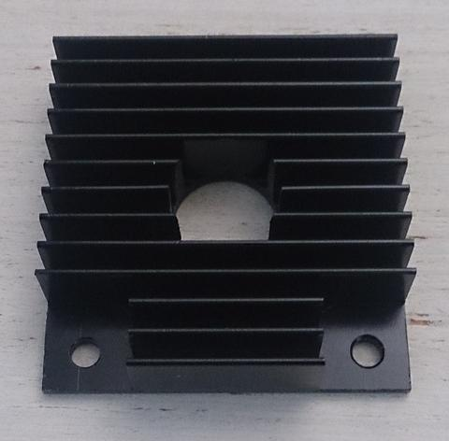

Heat Sink

* **Thermistor**: It is basically a sensor attached to the nozzle. It measures the temperature of the hot end.
* **Nozzle:** An object which allows the melted filament to come out.

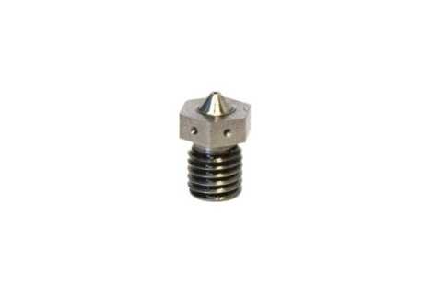

Nozzle

### **Heat sink cooling fan: For cooling the Extruder down.**

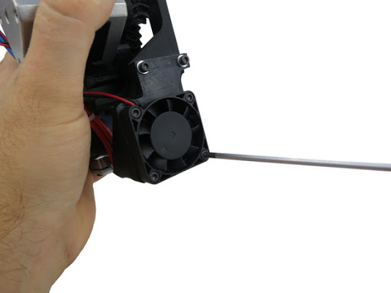

Cooling Fan

### **Threaded Rods / Leadscrews:** Used on the printer’s Z axis. They rotate, thus expelling the nuts to move up and down.

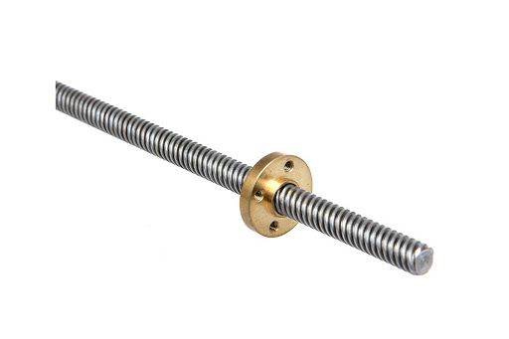

Lead Screw

### **Belts:** Belts move the Extruder or Heat bed in to and fro direction.

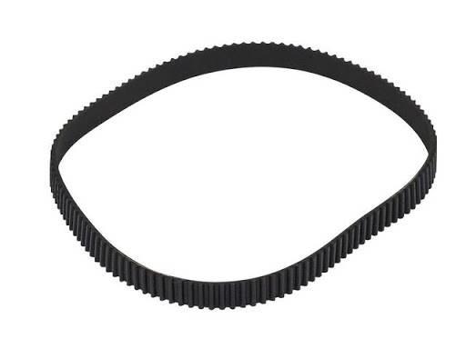

Belt

### **Stepper Motors:** Stepper motors rotate in steps. This gives them meticulous control over their position. Prusa i3 printers (or most printers) use NEMA 17 type motors with 200 steps per revolution.

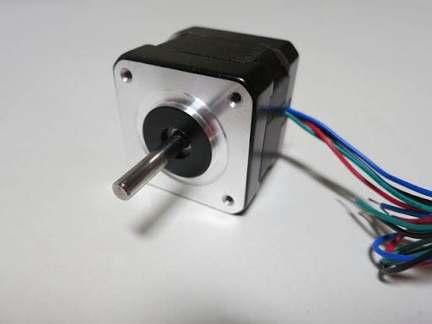

Stepper Motor

### **4.2** Electrical components:

### **Power Supply:** Takes the 120V AC electricity from the main supply and transforms it to low voltage DC power. They are efficient, and can distribute power at a variety of voltage.

### **Motherboard:** It takes the instructions given to it from the computer ([G-Code](http://reprap.org/wiki/G-code)) and executes it. The motherboard contains a microcontroller. Arduino is the most commonly used microcontroller.

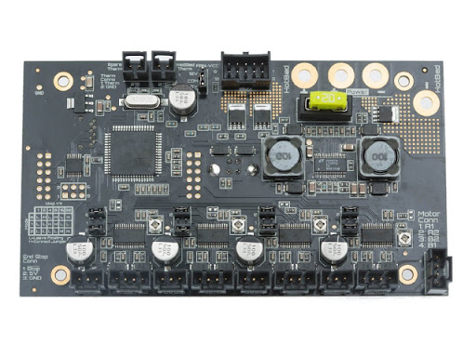

Motherboard

### **Stepper Drivers:** Accountable for driving the stepper motors. They trigger the coils of the motor, making it to rotate in steps. Many motherboards have the stepper drivers built in, but some also have them in modules that can be unplugged. They also control how much electrical current is supplied to the motor.

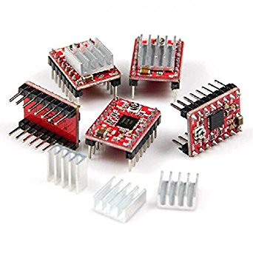

Stepper Driver

### **User interface:** LCD screen is interfaced to control the device without the need of a Computer.

## 4.3 Steps to assemble Prusa i3 Printer

**Assembling of X- and Z- axes**

* Assemble the X axis motor end and X end.
* Remove the support from the X end.
* Put a screw in the idler holder. This will be used to tighten the belt.
* Mount the Z axis stepper motors onto the frame.
* Place the motor coupling on the stepper motor and fix the hex screws.
* Insert the threaded lead rod into the coupling.
* Use the smooth rods to make the X axis with the X end, X motor mount and X Extruder carriage.
* Assemble the Z axis using the smooth rods. Place the X axis over the Z axis.
* Fix the top of the Z axis. Connect the belt to the X axis and tighten it.
* Fix the heat bed rail using a cable tie on each of the four corners.

**Assembling of Y- Axis**

* Use an Allen key to put the pulley onto the motor.
* Impose the motor and the motor holder together. Use the washer and a lock (Preferably Nylon) to hold the bearing into the idler.
* Settle the heat bed rails and rods.
* The distance between the rails should be about 16.2cm.
* Put the Y-belt-holder and the Y fame together. Place the frame on the bearings and tighten the rails using cable tie.

**Assembling the Heat Bed**

* Take large wires and solder it at the end.
* Lay a portion of solder on the pad of the heat bed and solder it with the wire.
* Assemble the heat bed on all four corners by using compression springs.
* Position the printing sticker on the glass plate. Carefully lay down the glass perpendicular to the printing sticker to avoid any bubbles.

**Assembling the Extruder**

* Screw the nozzle into the nozzle holder. Tighten it.
* Place the heater and thermistor into the heater block.
* Mount the idler to the extruder body and insert a gear through the bearing.
* Mount the extruder body to the X carriage.

## 4.4 Calibration of X, Y and Z axes

* Press the LCD-knob to enter the main menu on LCD. Rotate and push the button to choose preheat option. Choose a material then select with LCD-knob.

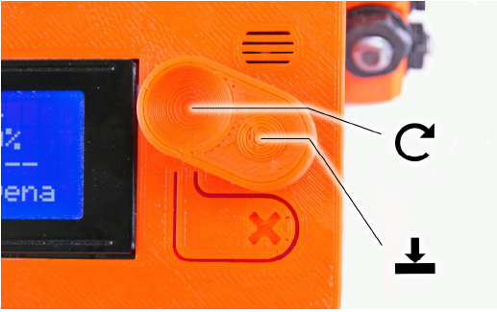

A picture displaying LCD-knob

* Choose the Auto home option. This brings all axes to 0,0,0 (Home) position. Axes stops its movement when they touch their corresponding End stop switches.
* Situate and move a paper between the bed and nozzle. A slight friction between the paper and the nozzle must be felt. Nozzle-bed distance adjusted by using the movement of Z axis. This step should be recapitulated in all four corners of the heat bed.

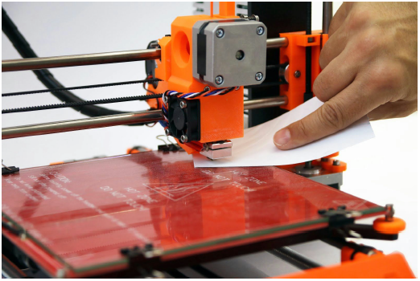

Printer calibration using the calibration paper

Problems of Incorrect calibration:

Figures show when nozzle-bed gap is different.

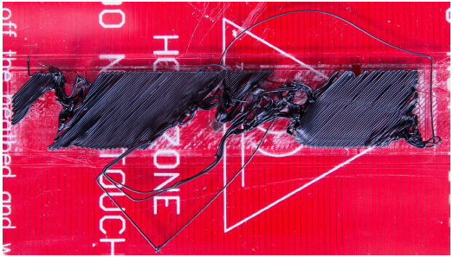

Figure 1: Nozzle is too far from the glass. Filament couldn’t attach properly and tears out.

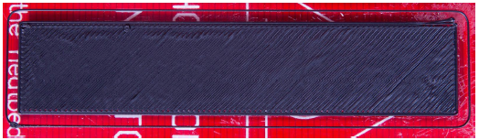

Figure 2: Calibrated printer shows continuous filament layers.

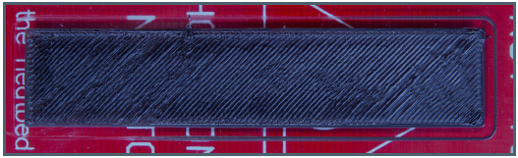

Figure 3: Nozzle too close to the glass. Layers are too compressed.

**4.5** Filling the extruder with Filament**:**

* Nozzle must be preheated to a certain temperature before inserting the filament to the Extruder. The temperature depends on the filament material.
* Top portion of the filament must be cut in an angle before loading. Filament is then loaded to the extruder by the extruder stepper (by manually moving the stepper motor) once the preheating is completed.

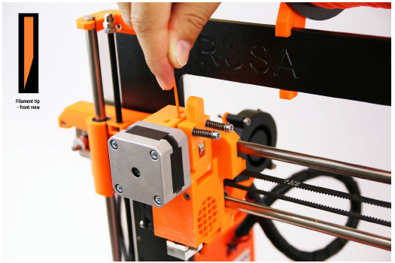

Figure: Loading the filament to the extruder

# Software

* The Software used for 3D Printing is “Cura”.
* Supports STL, OBJ and 3MF formats of the design.
* The file which requires to be analysed is arranged in thin layers by a software known as Slicer.
* This is converted into G-code (a programming language controlled numerically) to move the automated parts of the printer.
* Then the software along with this code direct the printer to print.
* Into the bargain, various settings can be adjusted like infill density and pattern, printing and heat bed temperature and print speed.

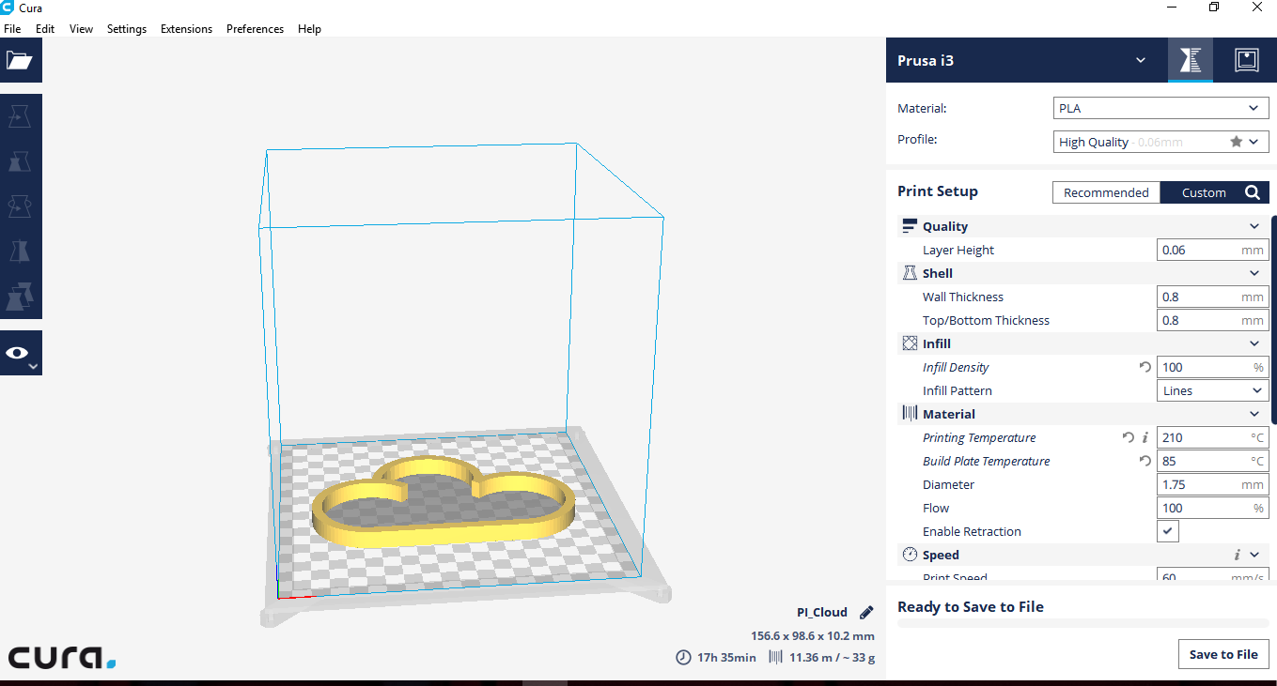

Schematic of Cura Software

**Steps to use Prusa i3 by using Cura:**

* Make sure to Calibrate the machine (distance between the nozzle and the heat bed must remain the same all the time during its working) before operation.
* Place all the axis in home position by clicking Main Menu 🡪 Prepare 🡪 Auto Home.
* Select the Printer which is required as follows.

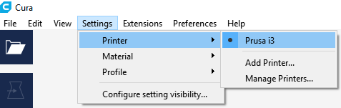

Step to select the printer

* Changing of material is shown in the figure.

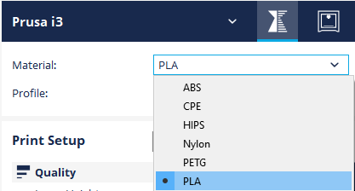

Step to select the material

* Additional settings suitable for the design to be printed can also be modified.

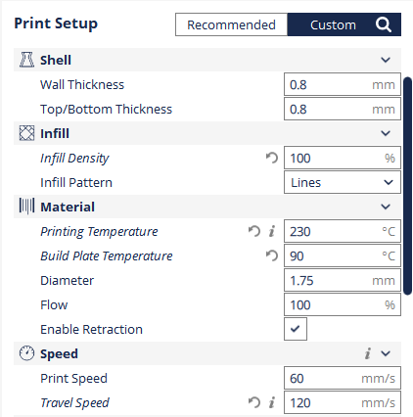

Further parameters

* Upload the file in any of the aforementioned formats on Cura.
* Adjust the size of the image according to the requirement (Time to print will also be displayed).
* Select print by clicking “Print via USB” option.
* SD card option is also available. This is the better option as USB printing might result in the communication mismatch which lack the print quality.

# Firmware update and trouble shooting

Firmware used for commanding the Microcontroller is Marlin. Updated to the version 1.1.3. Usually the changes are made in configuration.h file of the firmware for eliminating the bugs which will reflect the changes in all the other files.

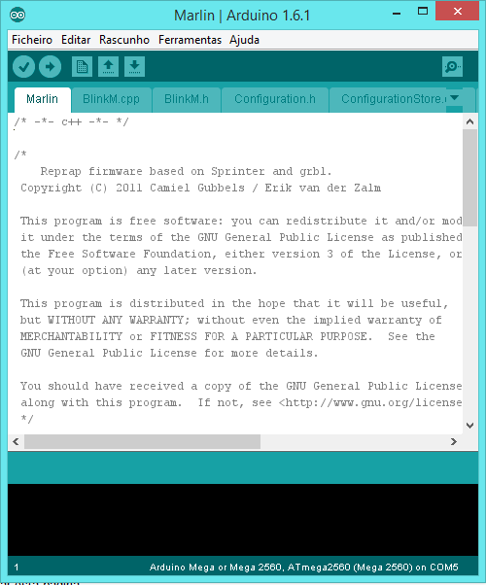

Schematic of Marlin firmware

The following changes were made to remove the bugs:

* In order to increase the communication speed the baudrate is set to 250000 as we had issues related to speed with the old version.
* Disabled THERMAL_PROTECTION_HOTENDS, THERMAL_PROTECTION_BED and PIDTEMPBED to increase the speed of heatbed and hotend heating.
* Whenever the endstop switch was closed, the axis was still moving in the direction of the switch and the movement of the axis in the other direction was restricted. So, logic of the endstop was inverted as:

X_MIN_ENDSTOP_INVERTING = true

Y_MIN_ENDSTOP_INVERTING = true

Z_MIN_ENDSTOP_INVERTING = true

X_MAX_ENDSTOP_INVERTING =true

Y_MAX_ENDSTOP_INVERTING = false

Z_MAX_ENDSTOP_INVERTING = false

Z_MIN_PROBE_ENDSTOP_INVERTING = false

* The stepper motors were moving in the opposite direction. So, the stepper direction was inverted as:

#define INVERT_X_DIR true

#define INVERT_Y_DIR false

#define INVERT_Z_DIR true

* The motor of the extruder was rotating in reverse direction, because of this the filament was not coming out. So, the direction of extruder was inverted:

INVERT_E0_DIR false

* Changed the values of travel limits after homing as:

#define X_MIN_POS 120

#define Y_MIN_POS 120

#define Z_MIN_POS 150

#define X_MAX_POS 200

#define Y_MAX_POS 200

#define Z_MAX_POS 200

for printing in the desired direction, but there seemed trouble in the home position of X, Y and Z axes. So, the default values must be kept as:

#define X_MIN_POS 0

#define Y_MIN_POS 0

#define Z_MIN_POS 0

#define X_MAX_POS 200

#define Y_MAX_POS 200

#define Z_MAX_POS 200

**7 Possible Hardware faults and its solutions**

|  |  |  |
| --- | --- | --- |
| PROBLEMS | CAUSES | SOLUTIONS |
| 1. Drivers and Motors. | Motor is not working.  Jittering. | * Check the motor driver using Multimeter. If the Driver is working then the output of the multimeter display as 12V. * Calibrate the motors by adjusting the Potentiometer in the driver circuit (there will be a small knob to adjust) and axes parameters in the display.   Main Menu🡺Motion🡺 Axes🡺Distance to Calibrate🡺Select the motor to calibrate.  Do this Step until Motor works smoothly in all directions. |
| 1. Stuck Rotor. | * Faulty driver. * Inconsistent power supply. * Overloading | * Do the trouble shooting for the driver. * Vary the input current by adjusting the potentiometer knob. |
| 1. Humming noise. | * Rotor is stuck. (See the troubleshooting for this cause). * Faulty bearing. | * Do the trouble shooting for the rotor. * Replace the bearing or Motor. |
| 1. Abnormal noise. | * Loose connection. * Faulty bearing. | * Tighten the connections. * Replace the bearing. |
| 1. Burning smell. | * Burnt driver. * Burnt motor. | * Replace the driver. * Replace the motor. |

|  |  |  |
| --- | --- | --- |
| PROBLEM | CAUSES | SOLUTIONS |
| 6. Printing pauses while printing. | * Loss of communication with the computer. * Corrupt SD card or file. * Overheating electronics. | * Check the USB connection or check the ardinuo board. * Replace SD card or file. * Mount fans to cool down the electronic components. |
| 7. Hot end or heated print  bed stops heating | * Heating element failed. * Electronics board failure. * Power supply failure. * Broken wire. * Blown fuse. | * Replace heating element. * Replace electronics board. * Check power and replace if no power to electronics. For example, it is possible for 12v power to fail, making motors and heaters inoperable. * Check all wiring for stress fractures and loose connectors. Replace as needed. * Check and replace fuse. |
| 8. Stepper motor stops  working. | * Stepper driver failure. * Power supply failure. * Broken wire. * Blown fuse. | * Replace stepper driver. * Check power and replace if no power to electronics. For example, it is possible for the 12v power to fail making motors and heaters inoperable. * Check all wiring for stress fractures and loose connectors. Replace as needed. * Check and replace fuse. |
| 9. Extruder gears turn but  filament pauses before it  extrudes. | * Worn or damaged gears. * Loose hobbed bolt. | * Check gears for damage and replace. * Check large gear for rounded-out nut trap and replace gear. * Tighten hobbed bolt. |

|  |  |  |
| --- | --- | --- |
| PROBLEM | CAUSES | SOLUTIONS |
| 10. Scratching or clunking sounds when axes move. | * Insufficient lubrication. * Loose axis mechanism. | * Perform regular maintenance to clean and lubricate axis movement. * Check, replace, and tighten axis. |
| 11. Axes does not stop at endstop. | * Broken switch. * Broken or disconnected wire. | * Replace endstop. * Check and replace as needed. |
| 12. Burning smell from electronics. | * Short or electronics failure. | * Turn computer off immediately. Check electronics for damage. Remove 12v power and connect USB cable to check low-voltage operation. Replace all damaged components. |
| 13. Sparks, clicking, or smoke from electronics. | * Short or electronics failure. | * Turn computer off immediately. Check electronics for damage. Remove 12v power and connect USB cable to check low-voltage operation. Replace all damaged components. |
| 14. No lights or LCD display. | * Power supply failure. | * Replace power supply. |
| 15. Unexplained noises when axes move – not related to axis mechanism. | * Loose frame components. | * Check all frame components and tighten as needed. |
| 16. Axis runs into max stop. | * Improper homing. | * Make sure you home all axis before printing. |
| 17. Metal screech from Z-axis rods. | * Insufficient lubrication. | * Ensure threaded rods are lubricated with the proper lubrication.(e.g., PTFE grease). Check your manual for the correct type to use. |
| 18. Printer vibrates excessively so that it moves across table. | * Loose frame components. * Acceleration too high. * Print speed too high. | * Check all frame components and tighten as needed. * Check acceleration settings in firmware. Reduce by 10%. * Lower infill print speed. |

# Further updates

Levelling a 3D manually is a task that might consume time. A person should be focused while handling this task and if distracted it could hamper the process. Therefore automatic levelling of Z axis in relation with the Heat bed is made.

It is the ability to tune the Z axis in such a way that the distance between nozzle and heat bed remains perfect in all places at all the time. Auto-level is done by the virtue of a proximity sensor. It works like this. When it is activated, the sensor calculates the distance between the nozzle and the bed by moving over it. If there are any bumpy surfaces on the bed, the firmware will make changes in the Z axis so that the nozzle will maintain constant distance with the bed. This will make use of End stop for Z axis less sufficient. Moreover, inclined print beds can also be introduced to this technology.

Furthermore, more updates can be included like addition of Bluetooth, zigbee, SCADA and much more.

# Conclusion

Many challenges were faced for Prusa i3. The important thing to notice is to analyze the calibration of Z axis with the heat bed and to make sure that the Nozzle prolongs a predetermined distance with the bed. Could improvise if metallic X end holder and idler is opted as aging can affect the synthetic ones which in turn anguish the machine. In addition, pre-configuration safety features like Thermistor and Heat bed temperature protection and PID (Proportional Integral and Derivative) setting of Heat bed must be considered to keep the controller and the device from destroying itself. Besides its minor faults, it is a good version of 3D printer.

# References

* [http://www.prusaprinters.org](http://reprap.org/wiki/Marlin)
* <http://reprap.org/wiki/Marlin>
* <http://reprap.org/wiki/RAMPS_1.4>
* <http://reprap.org/wiki/StepStick>
* <https://www.arduino.cc/en/Main/ArduinoBoardMega2560>
* <https://github.com/MarlinFirmware/Marlin>
* <http://www.prusa3d.com/downloads/manual/prusa3d_manual_175_en.pdf>
* <https://www.youtube.com/user/ThomasSanladerer>
* <http://forums.reprap.org/read.php?4,614214>
* [https://www.simplify3d.com/support/print-quality-troubleshooting/#extruding-too-much-plastic](https://www.simplify3d.com/support/print-quality-troubleshooting/)
* <https://3dprintingforbeginners.com/troubleshoot-3d-printing-problems/>
* <https://all3dp.com/1/common-3d-printing-problems-troubleshooting-3d-printer-issues/>
* Maintaining and Troubleshooting Your 3D Printer by Charles Bell
* “3D Printing For Dummies” by Kalani Kirk Hausman
* “3D Printing with SketchUp” by Marcus Ritland